Solution Architecture: HematoVision -

Advanced Blood Cell Classification

|  |  |
| --- | --- |
| Date | 10 June 2025 |
| Team ID | LTVIP2025TMID33915 |
| Project Name | Hematovision: Advanced Blood Cell Classification |
| Maximum Marks | 4 marks |

# Introduction

This document outlines the solution architecture for HematoVision, an AI-powered system designed for the accurate and efficient classification of blood cells. The architecture leverages a combination of deep learning models and a user-friendly web application to provide a robust and scalable solution for pathologists and healthcare professionals.

# High-Level Architecture Overview

The HematoVision system follows a typical client-server architecture, where a web-based frontend interacts with a Python-based backend that hosts the machine learning model.

The core components include:

* **Client-Side (Web Browser):** User interface for interacting with the system.
* **Web Application Backend (Flask):** Handles user requests, manages image uploads, and orchestrates interactions with the machine learning model.
* **Machine Learning Model (TensorFlow/Keras):** The trained deep learning model responsible for blood cell classification.
* **Storage:** For temporary storage of uploaded images.

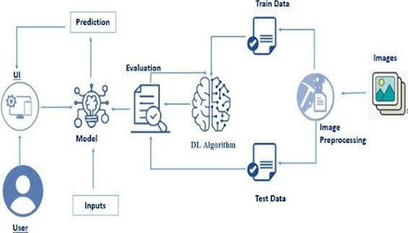

# Detailed Component Breakdown

## Client-Side (Frontend)

* **Technology:** HTML, CSS, JavaScript (standard web technologies).
* **Purpose:** Provides the graphical user interface (GUI) for users to interact with the HematoVision system.
* **Key Functions:**
* **Image Upload:** Allows users to select and upload blood cell images (e.g., home.html ).
* **Display Results:** Presents the classification prediction and the uploaded image (e.g., result.html ).
* **User Feedback:** Potentially provides visual cues for upload progress or errors.

## Web Application Backend (Flask)

* **Technology:** Python, Flask framework ( app.py ).
* **Purpose:** Acts as the central hub, receiving requests from the frontend, processing them, and returning responses. It integrates the machine learning model.
* **Key Functions:**
* **API Endpoints:** Defines routes for image upload ( /predict ) and serving web pages ( / ).
* **Image Handling:** Receives uploaded image files, saves them temporarily, and prepares them for model inference.
* **Model Inference Orchestration:** Loads the pre-trained blood_cell.h5 model and passes the processed image data to it for classification.
* **Result Processing:** Receives the prediction from the model and formats it for display on the frontend.
* **Error Handling:** Manages invalid file types or other processing errors.
* **Templating:** Renders HTML templates ( home.html , result.html ) to serve dynamic content to the user.

## Machine Learning Model

* **Technology:** TensorFlow, Keras, MobileNetV2 ( model.ipynb , blood_cell.h5 ).
* **Purpose:** The core intelligence of the system, responsible for accurately classifying blood cells.
* **Key Functions:**
* **Image Classification:** Takes a preprocessed blood cell image as input and outputs a probability distribution over the four blood cell classes (Eosinophil, Lymphocyte, Monocyte, Neutrophil).
* **Feature Extraction:** The pre-trained MobileNetV2 acts as a powerful feature extractor.
* **Prediction:** Provides the final predicted class based on the model's output.
* **Training Details (from model.ipynb and README_HematoVision.md ):**
* **Architecture:** MobileNetV2 (pre-trained) with custom classification layers.
* **Dataset:** 12,500 augmented blood cell images from Kaggle.
* **Training:** 5 epochs (as per README), Adam optimizer, categorical cross-entropy loss.
* **Accuracy:** Approximately 85.3% validation accuracy.
* **Model Persistence:** The trained model is saved as blood_cell.h5 for deployment.

## Storage

* **Technology:** Local filesystem.
* **Purpose:** Temporarily stores uploaded images before they are processed by the model.
* **Key Functions:**
* **Temporary Uploads:** The static/uploads/ directory is used to store images uploaded by users via the web interface.
* **File Management:** Images are typically deleted after processing or after a certain period to manage storage space.

# Data Flow and Interactions

1. **User Interaction:** A user accesses the HematoVision web application through their browser, which loads home.html from the Flask backend.
2. **Image Upload:** The user selects a blood cell image and uploads it via the web form.

This HTTP POST request is sent to the /predict endpoint of the Flask application.

1. **Backend Processing:**
   * The Flask application ( app.py ) receives the uploaded image.
   * It saves the image temporarily in the static/uploads/ directory.
   * The image is then preprocessed (resized, normalized) to match the input requirements of the MobileNetV2 model.
   * The preprocessed image is passed to the loaded blood_cell.h5 model for inference.
2. **Model Prediction:** The MobileNetV2 model performs the classification and returns the predicted blood cell type.
3. **Result Display:**
   * The Flask application receives the prediction from the model.
   * It then renders the result.html template, passing the prediction and the path to the uploaded image.
   * The result.html page is sent back to the user's browser, displaying the classification outcome.

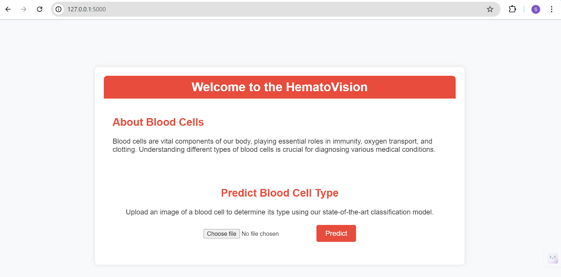

# Deployment Considerations

* **Containerization:** The application can be containerized using Docker for consistent deployment across different environments.
* **Cloud Platforms:** Suitable for deployment on cloud platforms like Render, Railway, or Heroku, as indicated in README_HematoVision.md .
* **Scalability:** For high traffic, the Flask application can be scaled horizontally, and the model inference can be offloaded to dedicated GPU-enabled services.
* **Security:** Implement secure coding practices, input validation, and secure handling of uploaded files.

# Future Enhancements

* **API for Integration:** Develop a dedicated API for external systems to integrate with the classification service.
* **Batch Processing:** Allow for the upload and classification of multiple images simultaneously.
* **Confidence Scores:** Display confidence levels for predictions to aid pathologists in decision-making.
* **Database Integration:** Store classification results and metadata in a database for auditing and analysis.
* **User Authentication:** Implement user login and role-based access control for secure access.